**Arithmetic Operations**

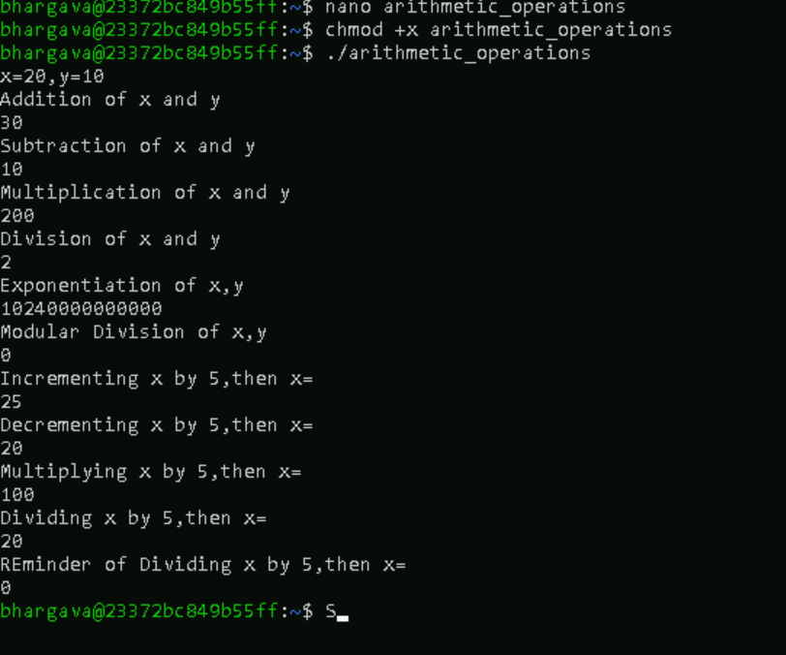

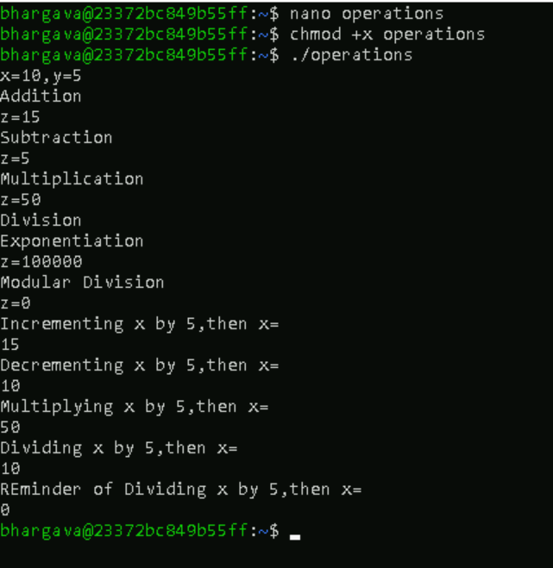

**Backticks**

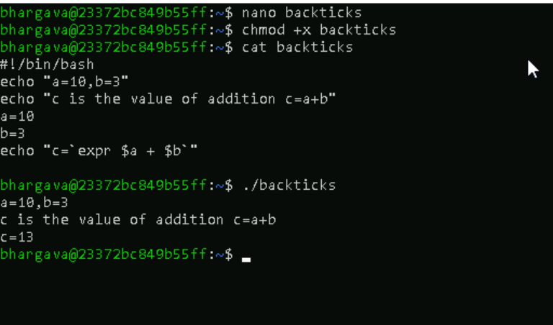

**Greater than Example**

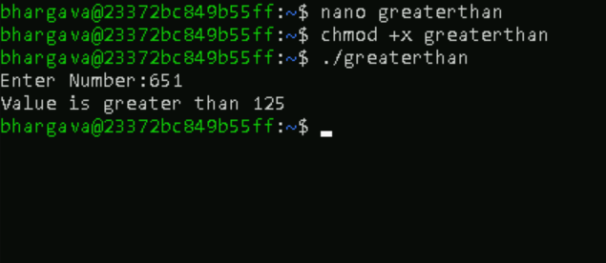

**Comparing two strings example**

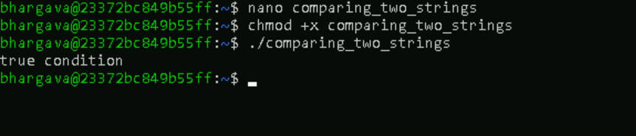

**Numbers Comparison**

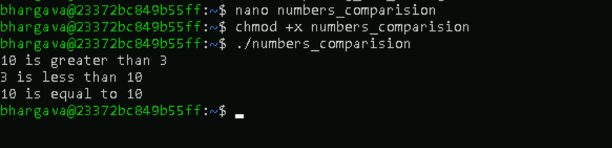

**And Operator**



**OR Operator**

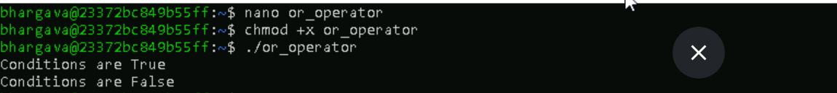

**And_OR Operators**



**Nested_if**

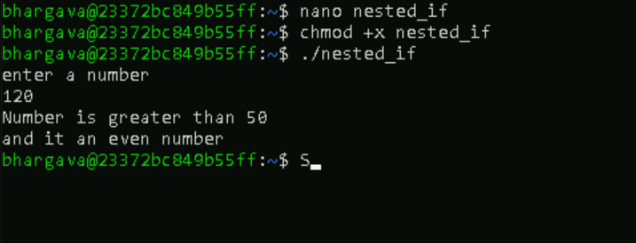

**Bash if else example1**

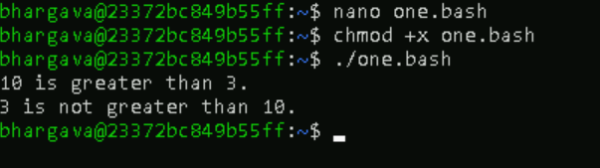

**Bash if else example2**



**Bash if else example3**

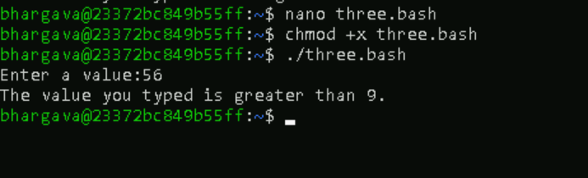

**Bash if else example4**

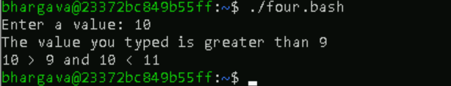

**Bash else if example1**

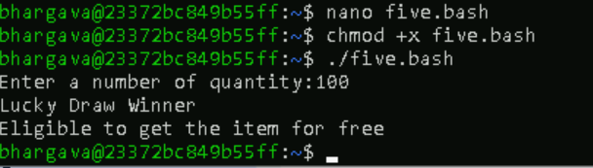

**Bash else if example2**

